Lab 12: Algorithms with AI Assistance – Sorting, Searching, and
Optimizing Algorithms
Lab Objectives:
• Apply AI-assisted programming to implement and optimize
sorting and searching algorithms.
• Compare different algorithms in terms of efficiency and use cases

Understand how AI tools can suggest optimized code and
complexity improvementsTask Description #1 (Sorting – Merge Sort Implementation)
• Task: Use AI to generate a Python program that implements the
Merge Sort algorithm.
• Instructions:
o Prompt AI to create a function merge_sort(arr) that sorts a
list in ascending order.
o Ask AI to include time complexity and space complexity
in the function docstring.
o Verify the generated code with test cases.
• Expected Output:
o A functional Python script implementing Merge Sort with
proper documentation

Prompt: Write a Python function merge_sort(arr) that sorts a list in ascending order.
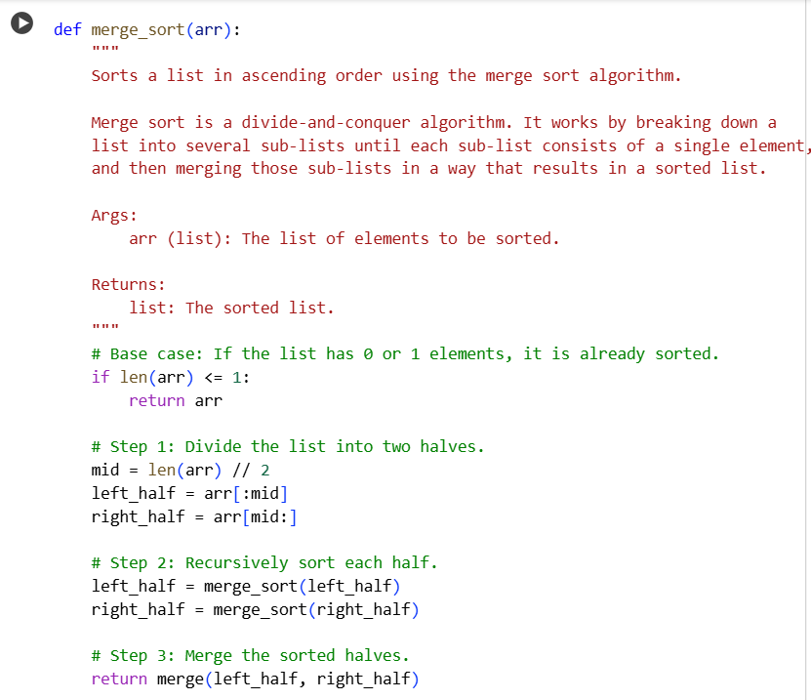

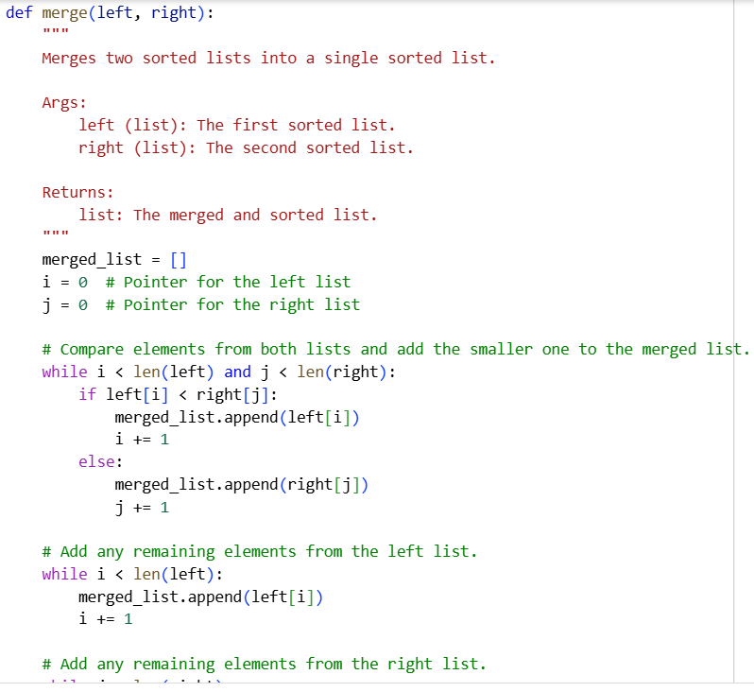
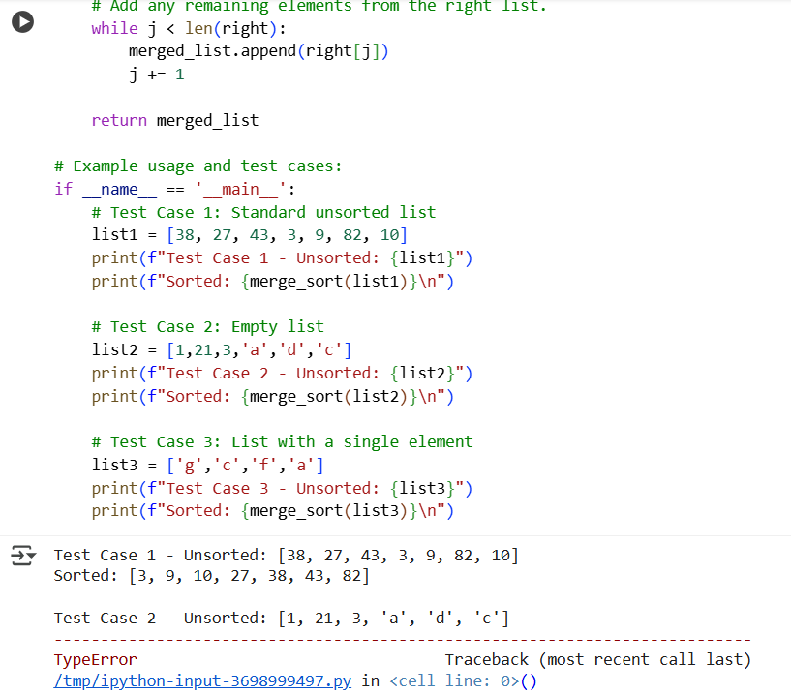

Observation:the code was able to take integerds and alphabets and sorting thm.but when given combination of both,it is throwing an error.We can modify the code to take combination of both or give a message that combination ofo both are not accepeted based o our requirements.

Task Description #2 (Searching – Binary Search with AI
Optimization)
• Task: Use AI to create a binary search function that finds a target
element in a sorted list.
• Instructions:
o Prompt AI to create a function binary_search(arr, target)
returning the index of the target or -1 if not found.
o Include docstrings explaining best, average, and worst-
case complexities.
o Test with various inputs.
• Expected Output:
o Python code implementing binary search with AI-
generated comments and docstrings

Prompt: Write a Python function binary_search(arr, target) that returns the index of target or -1. Include docstrings with best, average, and worst-case complexities.

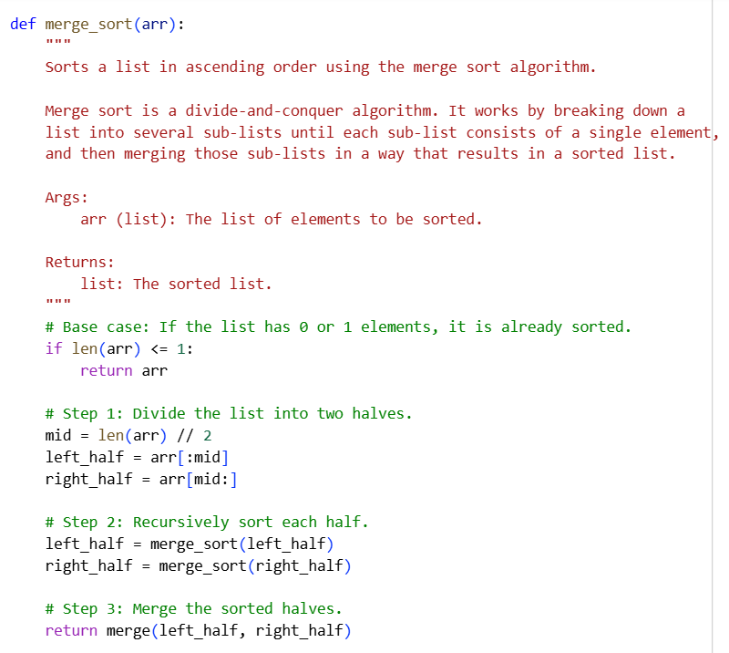
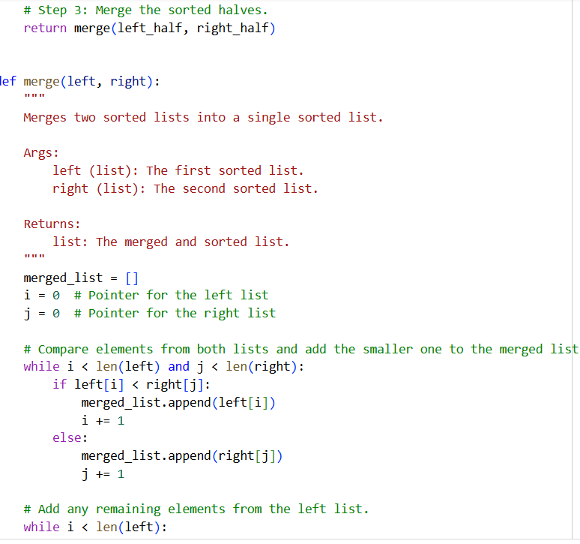

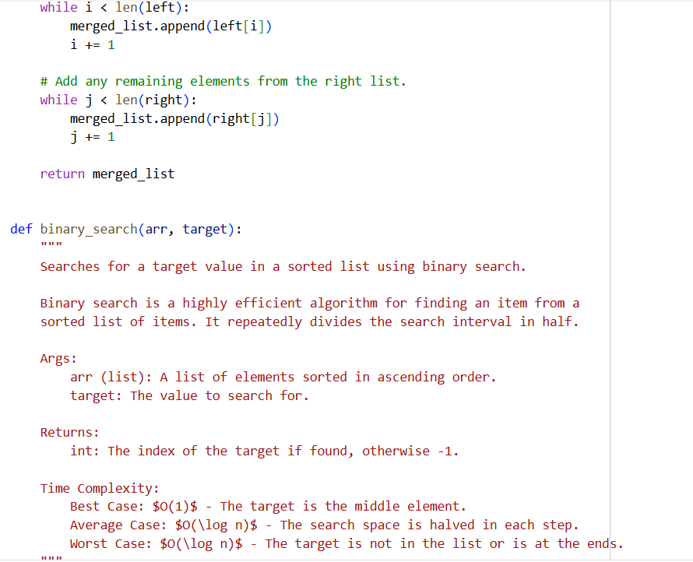
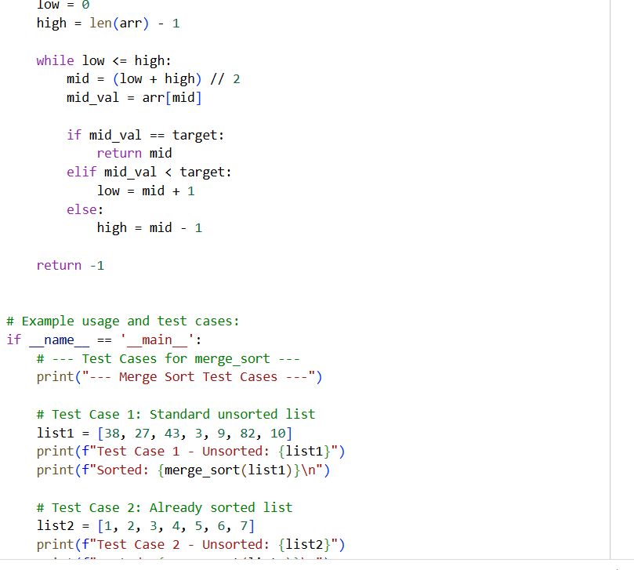

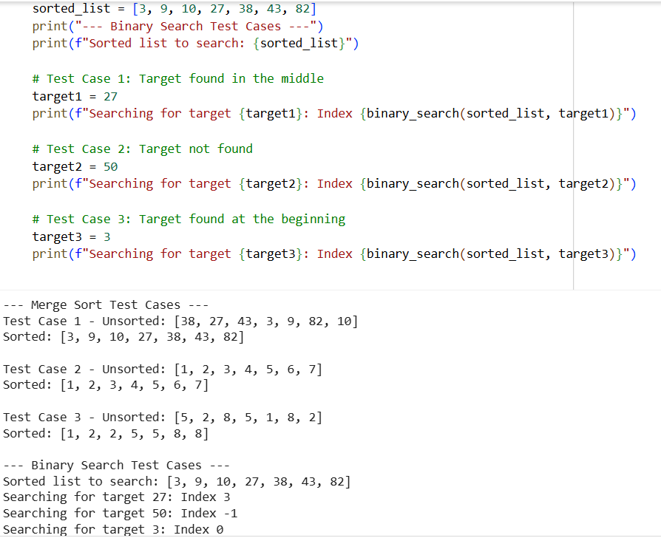

Task Description #3 (Real-Time Application – Inventory
Management System)
• Scenario: A retail store’s inventory system contains thousands of
products, each with attributes like product ID, name, price, and
stock quantity. Store staff need to:
1. Quickly search for a product by ID or name.
2. Sort products by price or quantity for stock analysis.
• Task:
o Use AI to suggest the most efficient search and sort
algorithms for this use case.
o Implement the recommended algorithms in Python.
o Justify the choice based on dataset size, update frequency,
and performance requirements.
• Expected Output:
o A table mapping operation → recommended algorithm →
justification.
o Working Python functions for searching and sorting the
inventory

